Too old for stories? Think again!
You haven’t heard stories from the collection of ghost tales, urban legends, and down-right spooky accounts of Rebecca and Rachel Oshlag, professional storytellers.
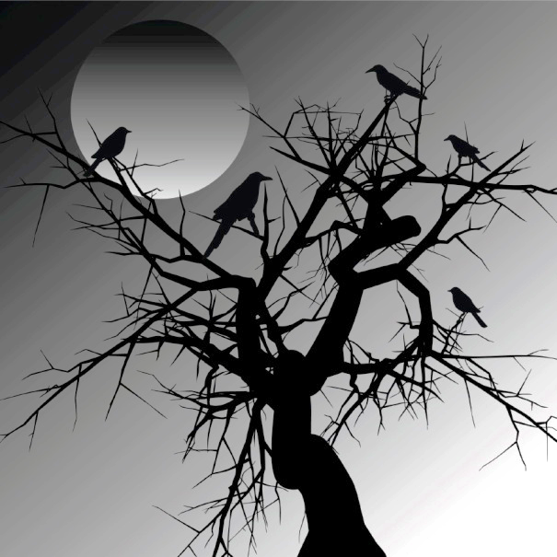
Session 1: Scary Stories and Tellers’ Techniques
Monday, January 9, 2017 from 3:00 to 4:00 in the Gallery Room.
After telling a few bone-chilling tales, Rachel and Rebecca will reveal some of their secrets of finding, and preparing spooky stories! They will help you select a story and change it to make it your own. They will give you tips on learning your tale. You’ll be surprised how easy this is.

Session 2: Getting Ready to Tell Your Story
Monday, January 16, 2017 from 3:00 to 4:45 in the Gallery Room
Bring your scary story with you, and the storytellers will help you get ready to tell it! Be ready to hear another story by Rachel or Rebecca and figure out their tricks to make the story sound real and scary. There will be games and activities to make the learning easy and fun.

Session 3: Time to Tell
Monday, January 23 2017: 3:00-4:00 in the Gallery Room
Get ready to hear your friend’s stories…..and share your own!
A note to parents: We are pleased to offer a three-session workshop session for middle school students who attend After School @ Your Library. The set of workshops will teach students to develop and tell their own spooky story or urban legend. Each participant will have an opportunity to share the story that they adapt.
While our stories are designed to thrill and chill, they are not gory or violent. They do not rely on horror imagery for effect. Stories that we tell or use as examples are drawn from folktales and age-appropriate books of spooky stories. There is no cost to this program. Rebecca and Rachel Oshlag, Storytellers

